

**CENTRAL BOARD OF SECONDARY EDUCATION**

**ALL SAINT’S CHURCH SR.SEC. SCHOOL**

**M.I. ROAD , JAIPUR**

A PRACTICAL RECORD FILE IS SUBMITTED TO DEPARTMENT OF INFORMATICS PRACTICES FOR THE PARTIAL FULLFILLMENT OF SSCE EXAMINATION SESSION - _2023-24_

**SUBMITTED BY: [Mohammad Shayyan]**

**HOD(IP):[Mrs. Sharon Amus]**

**CLASS: [12th Science]**

CERTIFICATE

             This is to certify that  **[Mohammad Shayyan]** , student of Class XII, [**All Saint’s church Sr. Sec. School ]** has completed the **PRACTICAL FILE** during the academic year [2023-24] towards partial fulfillment of credit for the Informatics Practices practical evaluation of SSCE-2023-24 and submitted satisfactory report, as compiled in the following pages, under my supervision.

**Total number of practical certified are : 33**

Internal Examiner External Examiner

     Signature       Signature

Date:           School Seal

Principal                                      Signature

|  |  |  |  |
| --- | --- | --- | --- |
| **No** | **Practical** | **Date** | **Signature** |
| **1** | **Data handling using Pandas** | | |
| 1 | Find the sum of those values which are ending with 3 or 5. |  |  |
| 2 | Create a series of 10 numbers starting with 41 and with the increment of 3. Now add 7 all odd values and subtract 3 in even values. Reprint the updated series. |  |  |
| 3 | Create a series of 10 numbers. Change the value of all the elements those values are multiples of 4. |  |  |
| 4 | Create a series and print the top 3 elements using the head function. |  |  |
| 5 | Create a series and print the last 3 elements using the tail function. |  |  |
| 6 | Create a series with these numbers: 21, 51, 71, 31, 12. Exchange all these values of series by shifting each of them one to one position before and by shifting the first value to last position. |  |  |
| 7 | Create a dataframe named as students using a list of names of 5 students |  |  |
| 8 | Create a dataframe players using a list of names and scores of the previous three matches. (Using Nested list) |  |  |
| 9 | Create a dataframe **countries** using a dictionary which stored country name, capitals and populations of the country. |  |  |
| 10 | Iterate dataframe created in question no. 8 by its rows. |  |  |
| 11 | Print scores of previous two matches along with their names using iterrows function. (Use dataframe created in question 8) |  |  |
| 12 | Make a total of score from the dataframe players and display their rank according their scores. |  |  |
| 13 | Print the batsman name along with runs scored in Test and T20 using column names and dot notation. |  |  |
| **No** | **Practical** | **Date** | **Signature** |
| 14 | Display the Batsman name along with runs scored in ODI using loc. |  |  |
| 15 | Display the batsman details who scored   * More than 2000 in ODI * Less than 2500 in Test * More than 1500 in T20 |  |  |
| **2** | **Part 2 Data Visualization** | | |
| 16 | Plot following data on line chart and follow the given instructions:   |  |  |  |  |  |  | | --- | --- | --- | --- | --- | --- | | Day | Monday | Tuesday | Wednesday | Thursday | Friday | | Income | 510 | 350 | 475 | 580 | 600 |  * Write a title for the chart "The Weekly Income Report". * Write the appropriate titles of both the axes. * Write code to Display legends. * Display red color for the line. * Use the line style - dashed * Display diamond style markers on data points |  |  |
| 17 | Consider the following data of a medical store and plot the data on the line chart and Customize the chart as you wish:   |  |  |  |  | | --- | --- | --- | --- | | Month | Masks | Sanitizer | Hand wash | | March | 1500 | 4400 | 6500 | | April | 3500 | 4500 | 5000 | | May | 6500 | 5500 | 5800 | | June | 6700 | 6000 | 6300 | | July | 6000 | 5600 | 6200 | | August | 6800 | 6300 | 4500 | |  |  |
| 18 | Use above data and subplot sanitizer data and handwash data. |  |  |
| 19 | Display following bowling figures through bar chart:   |  |  | | --- | --- | | Overs | Runs | | 1 | 6 | | 2 | 18 | | 3 | 10 | | 4 | 5 | |  |  |
| **No** | **Practical** | **Date** | **Signature** |
| **3** | **Part 3 MySQL queries** | | |
| 20 | Consider the given table and write given queries :   1. To join product and company and display in the tabular form like - <pname> manufactured by <company> 2. Convert all product name into capital 3. Display the cube of products quantity more than or 100 4. Divide the price by 3 and display the result with 1 fraction digit for the price of more than 40,000. 5. Display pname (last four letters only), qty, price with 2 decimal points and company for price in between 30000 to 80000. 6. Display maximum price of products 7. Display the total quantities of all products 8. Display the average price of LED TV and Apple products 9. Find the difference between maximum price and minimum price from the table. 10. Display unique Products from the table. 11. Count the unique company from products. 12. Display the product number, product name and company in the descending order of their price. 13. Display product minimum price for each company. 14. Display product number and product names in their ascending order of names. 15. Display maximum price of products manufactured by apple. |  |  |

**Part 1: Data Handling Using Pandas**

1. **Create a series of these numbers:**

**33,55,65,29,19,23.**

**Find the sum of those values which are ending with 3 or 5.**

Code:

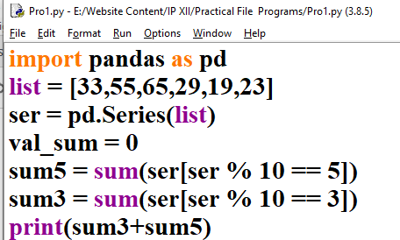

Output: 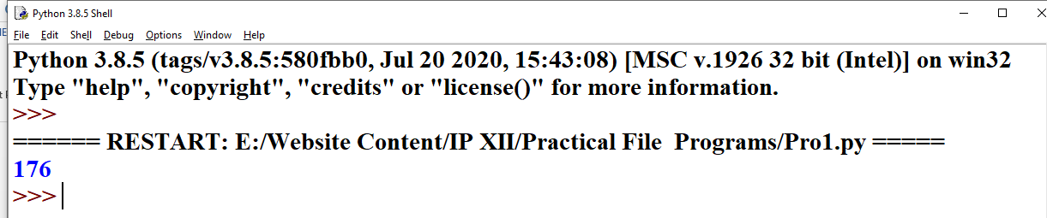

1. **Create a series of 10 numbers starting with 41 and with the increment of 3. Now add 7 all odd values and subtract 3 in even values. Reprint the updated series.**

Code:

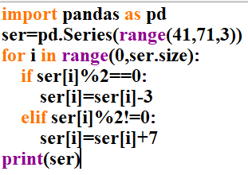

Output:

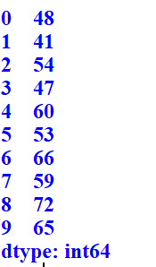

1. **Create a series of 10 numbers. Change the value of all the elements those values are multiples of 4.**

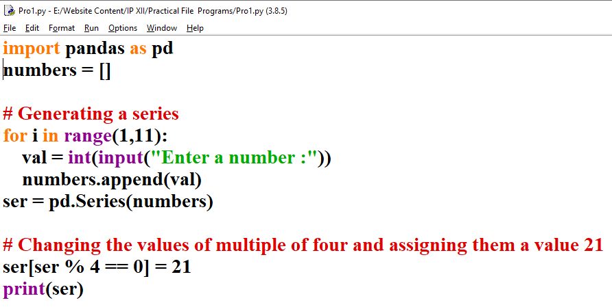Code:

Output:

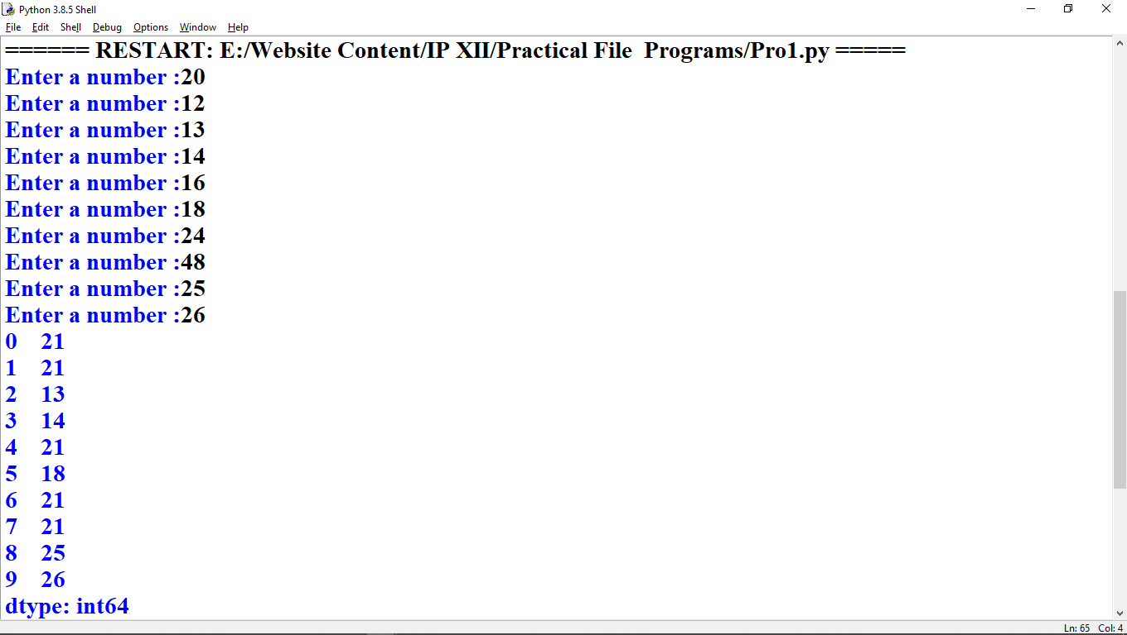

1. **Create a series and print the top 3 elements using the head function.**

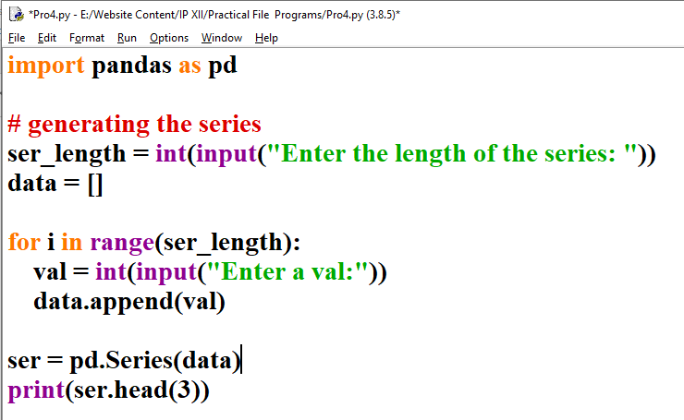Code:

Output:

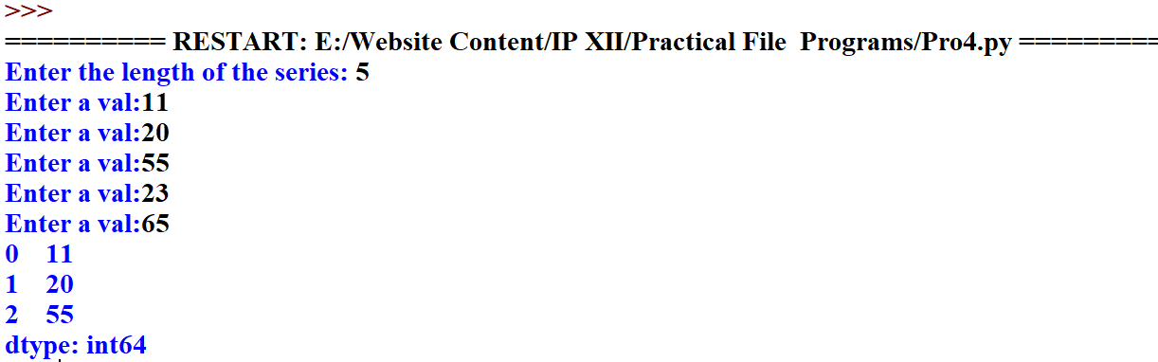

1. **Create a series and print the bottom 3 elements using the tail function.**

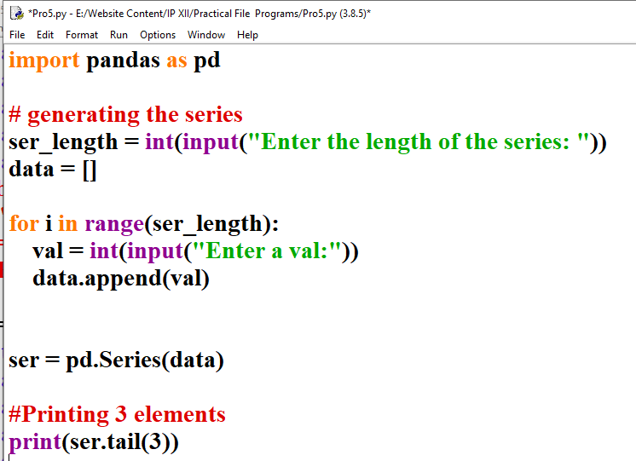Code:

1. **Create a series with these numbers: 21, 51, 71, 31, 12. Exchange all these values of series by shifting each of them one to one position before and by shifting the first value to last position..**

Code:

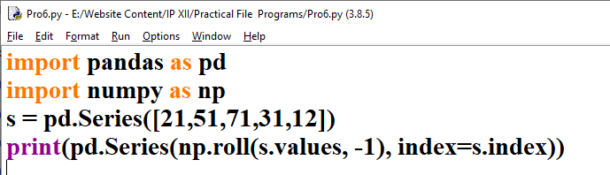

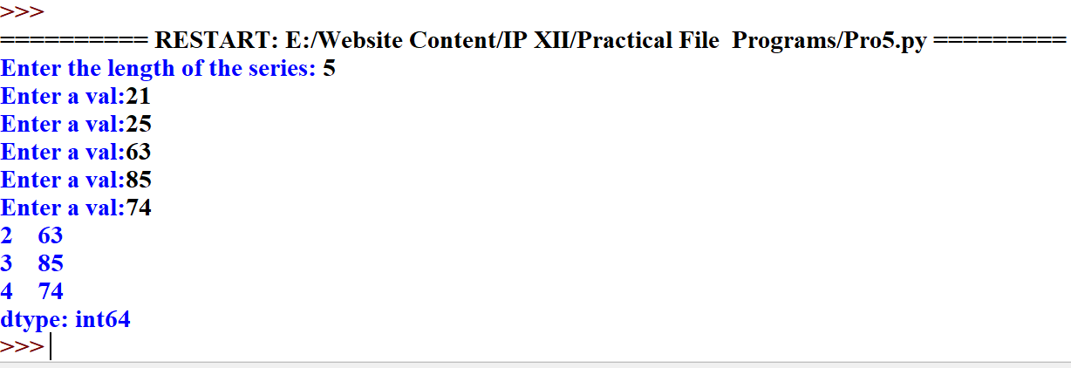Output:

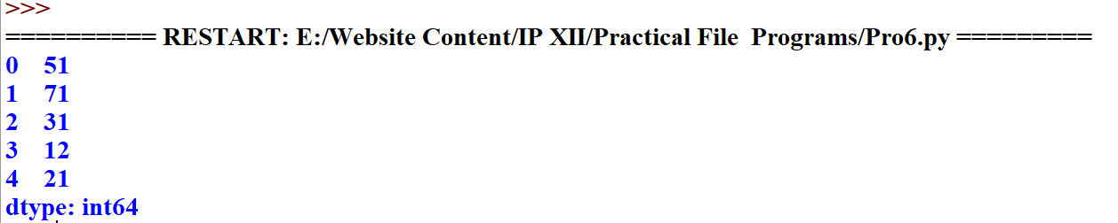

1. **Create a dataframe named as students using a list of names of 5 students.**

Code:

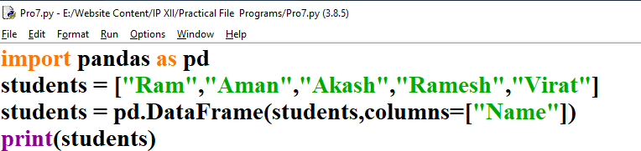

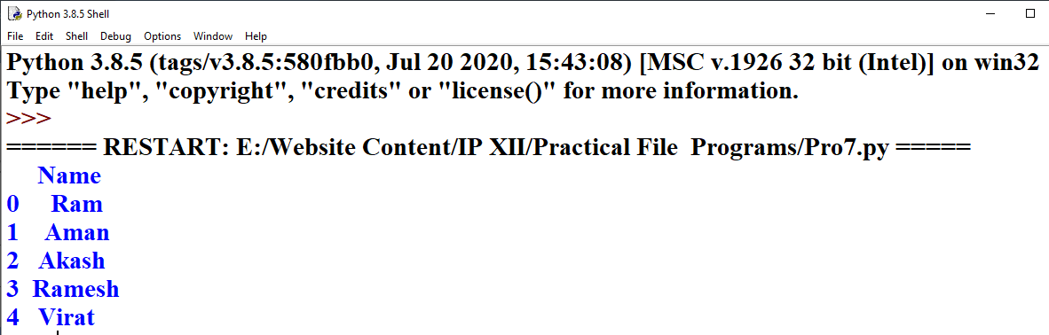 Output:

1. **Create a dataframe players using a list of names and scores of the previous three matches. (Using Nested list)**

Code:

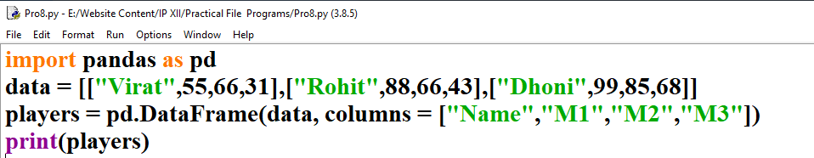

Output:

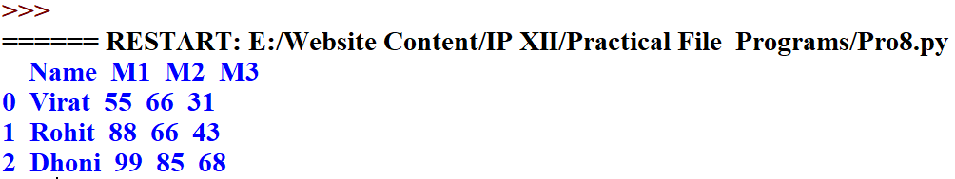

1. **Create a dataframe countries using a dictionary which stored country name, capitals and populations of the country.**

**Code:**

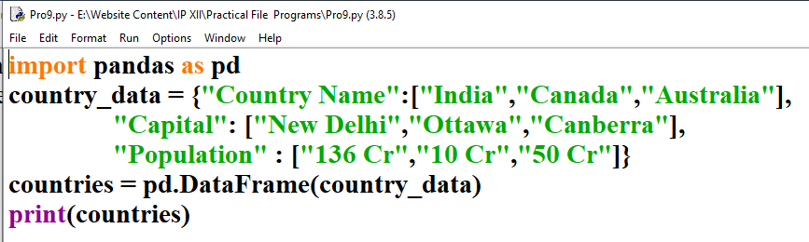

**Output:**

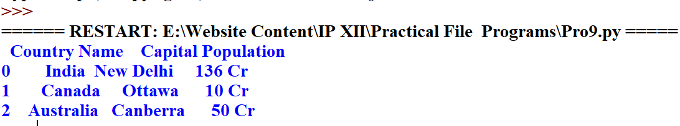

1. **Iterate dataframe created in question no. 8 by its rows.**

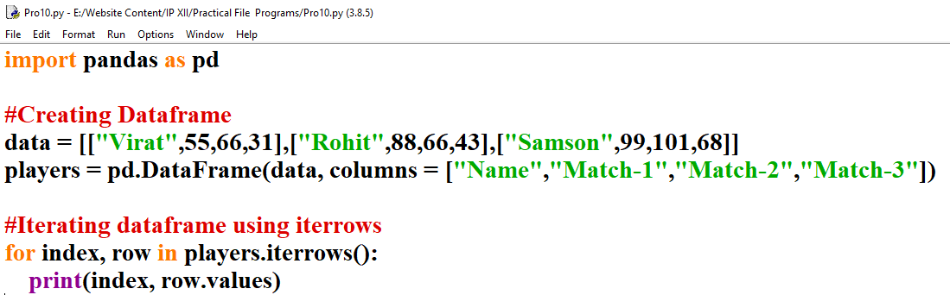**Code:**

**Output:** 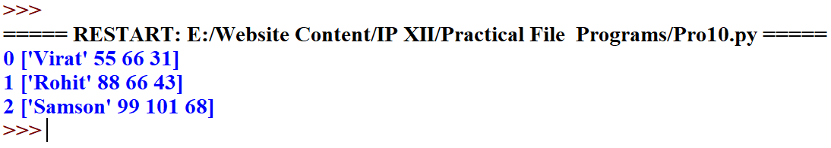

1. **Print scores of previous two matches along with their names using iterrows function. (Use dataframe created in question 8)**

**Code:**

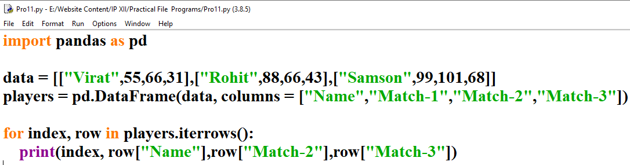

**Output:**

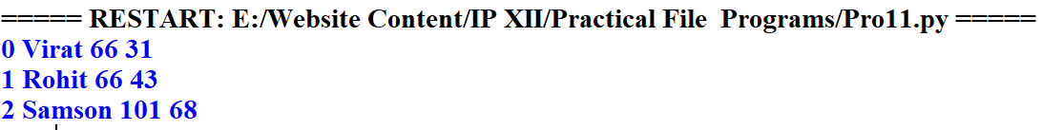

1. **Make a total of score from the dataframe players and display their rank according the their scores.**

**Code:** 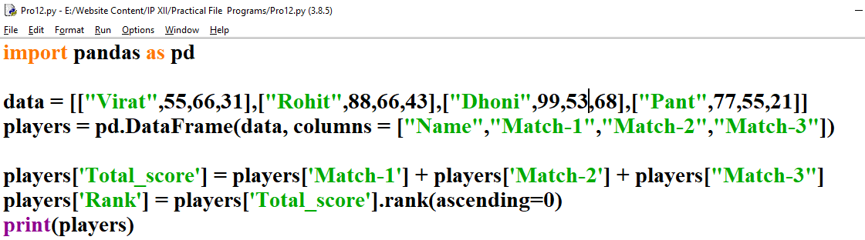

**Output:** 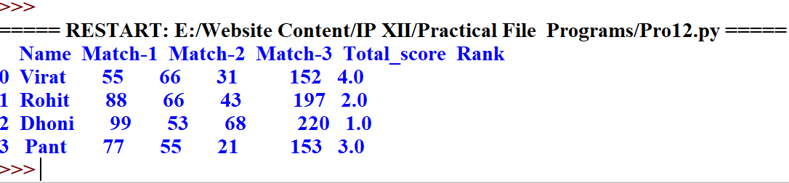

1. **Print the batsman name along with runs scored in Test and T20 using column names and dot notation.**

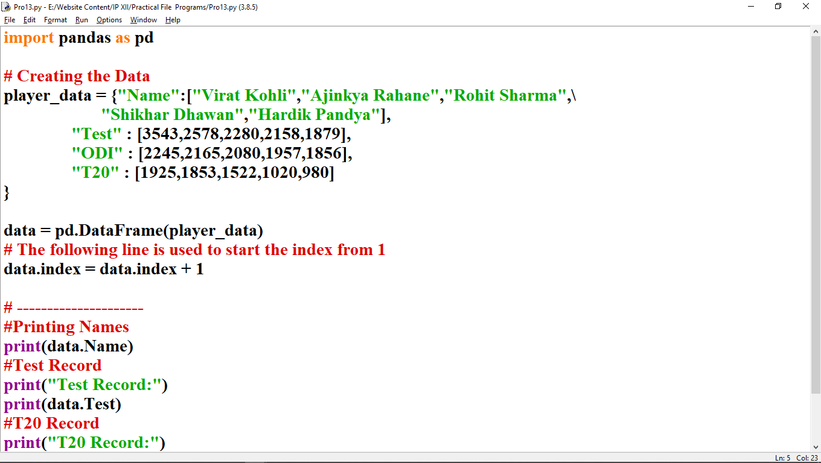**Code:**

**Output:**

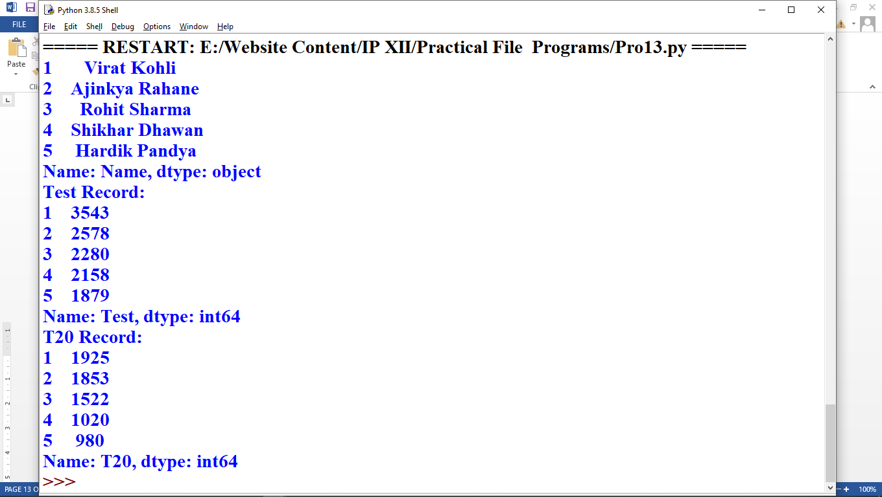

1. **Display the Batsman name along with runs scored in ODI using loc.**

**Code:**

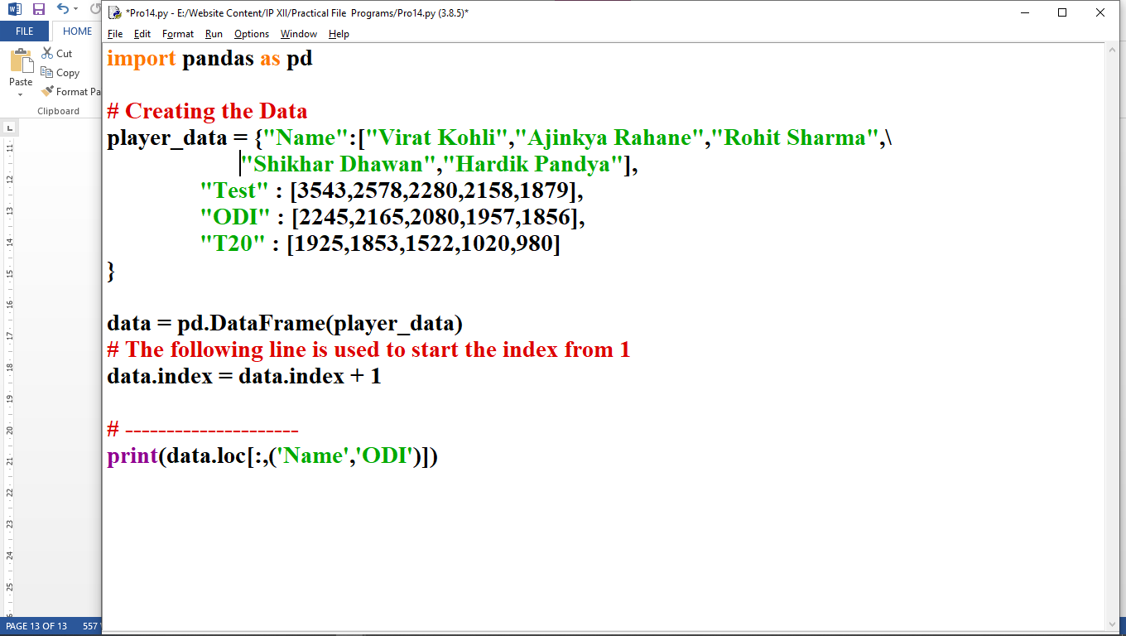

**Output:**

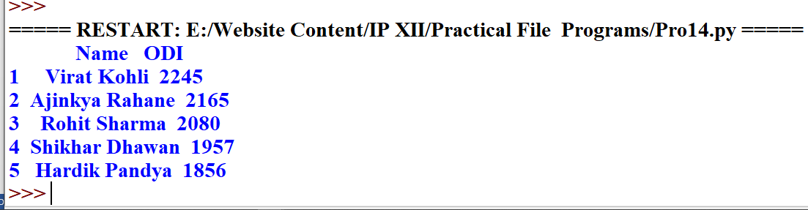

1. **Display the batsman details who scored**
   1. **More than 2000 in ODI**
   2. **Less than 2500 in Test**
   3. **More than 1500 in T20**

**Code:**

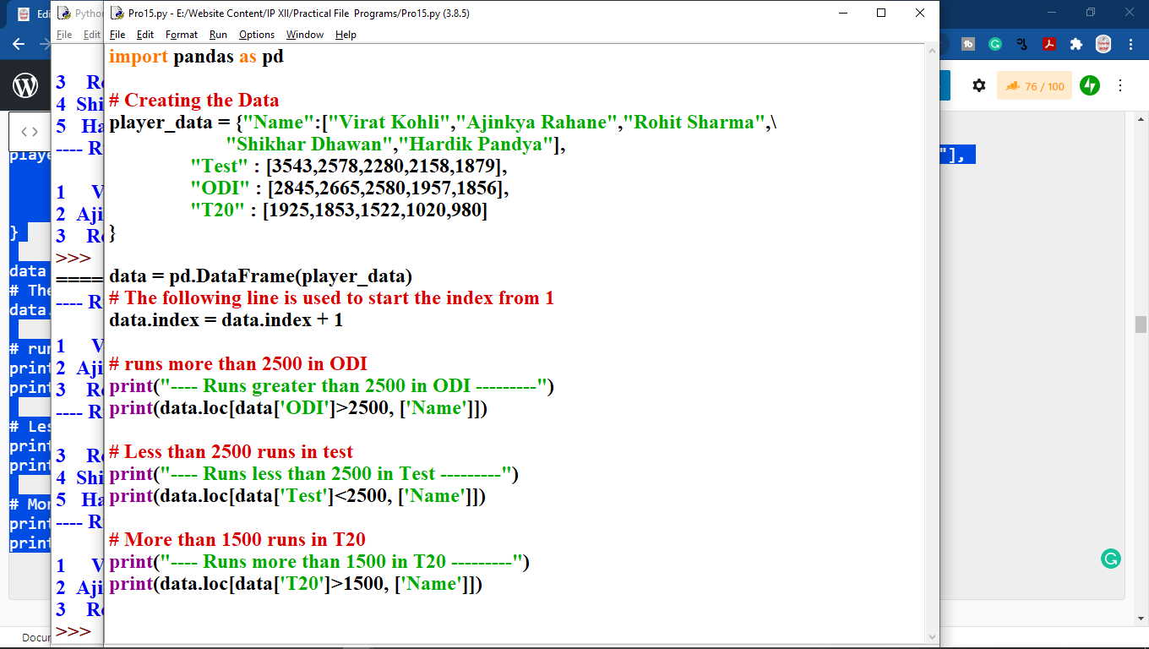

**Output:**

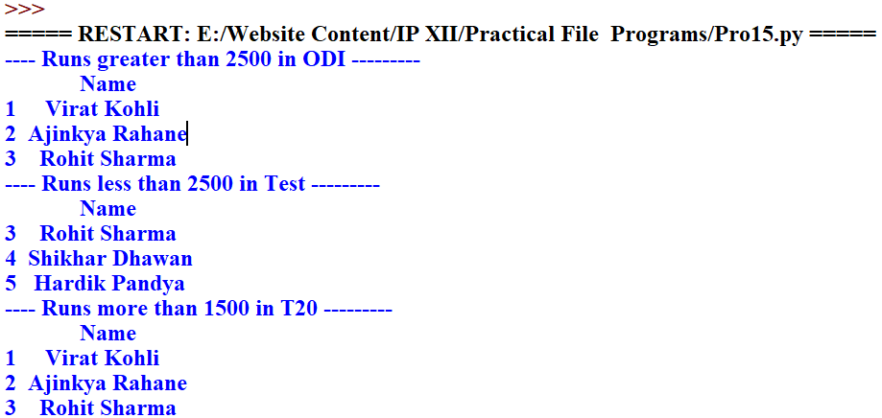

**Part 2: Data Visualization**

**16. Plot following data on line chart and follow the given instructions:**

|  |  |  |  |  |  |
| --- | --- | --- | --- | --- | --- |
| **Day** | **Monday** | **Tuesday** | **Wednesday** | **Thursday** | **Friday** |
| Income | 510 | 350 | 475 | 580 | 600 |

* 1. **Write a title for the chart "The Weekly Income Report".**
  2. **Write the appropriate titles of both the axes.**
  3. **Write code to Display legends.**
  4. **Display red color for the line.**
  5. **Use the line style - dashed**
  6. **Display diamond style markers on data points**

**Code:**

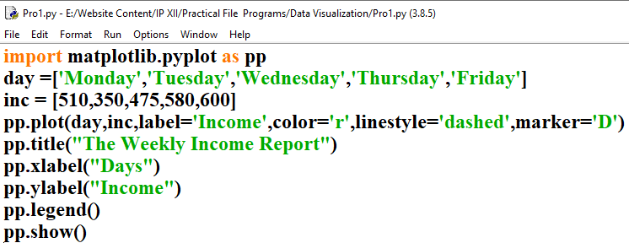

**Output:**

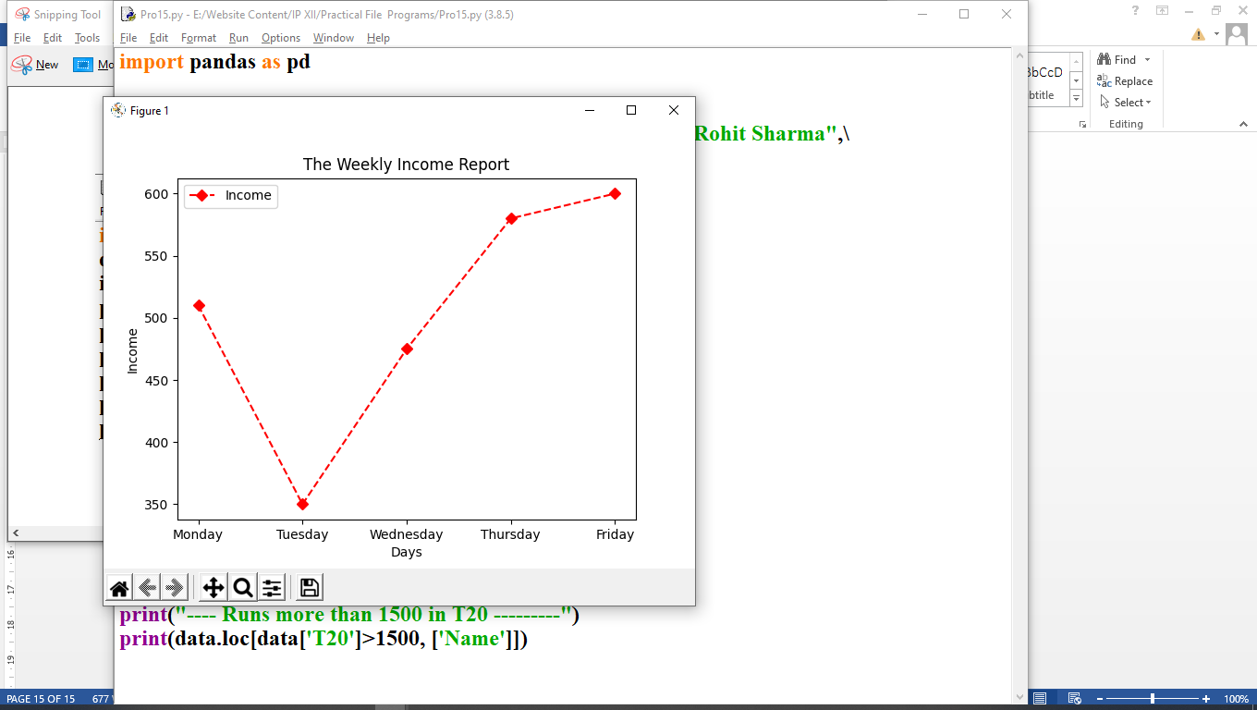

**17.Consider the following data of a medical store and plot the data on the line chart and Customize the chart as you wish:**

|  |  |  |  |
| --- | --- | --- | --- |
| **Month** | **Masks** | **Sanitizer** | **Hand wash** |
| **March** | **1500** | **4400** | **6500** |
| **April** | **3500** | **4500** | **5000** |
| **May** | **6500** | **5500** | **5800** |
| **June** | **6700** | **6000** | **6300** |
| **July** | **6000** | **5600** | **6200** |
| **August** | **6800** | **6300** | **4500** |

**Code:**

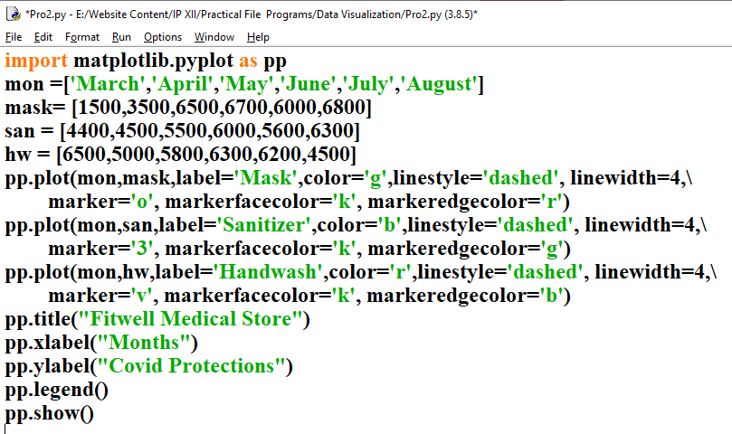

**Output:**

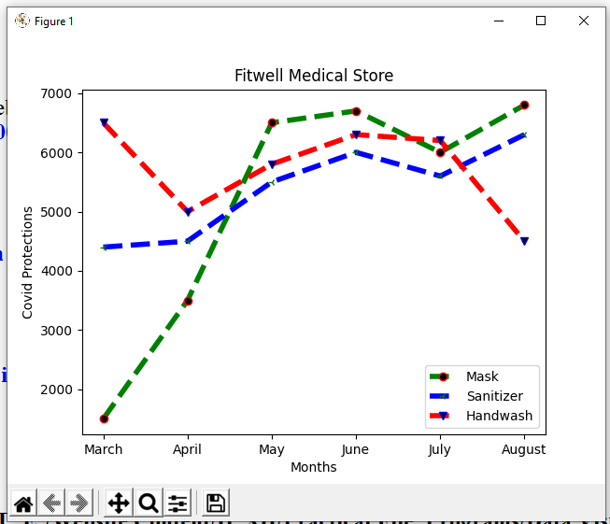

1. **Use above data and subplot sanitizer data and handwash data.**

**Code:**

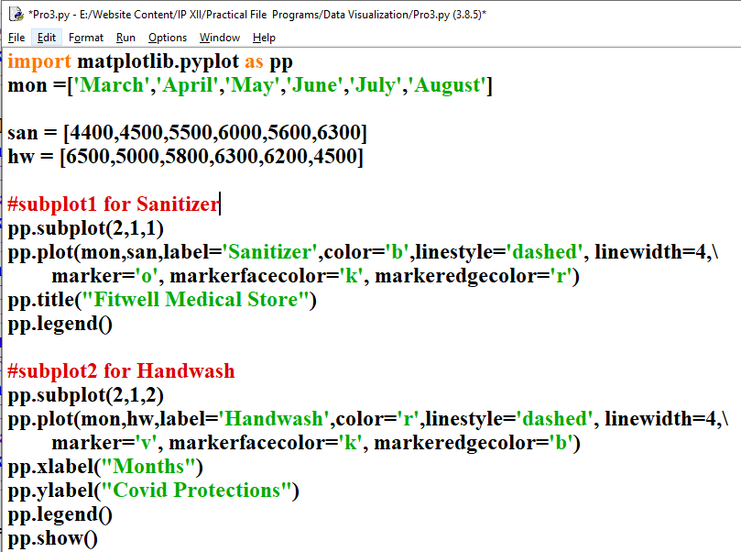

**Output:**

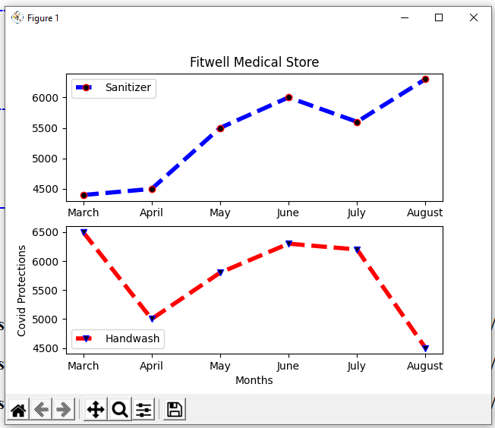

1. **Display following bowling figures through bar chart:**

|  |  |
| --- | --- |
| **Overs** | **Runs** |
| 1 | 6 |
| 2 | 18 |
| 3 | 10 |
| 4 | 5 |

**Code:**

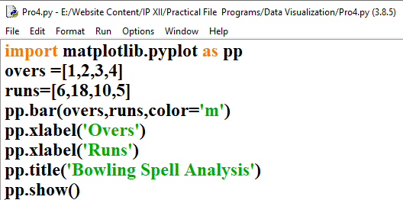

**Output**

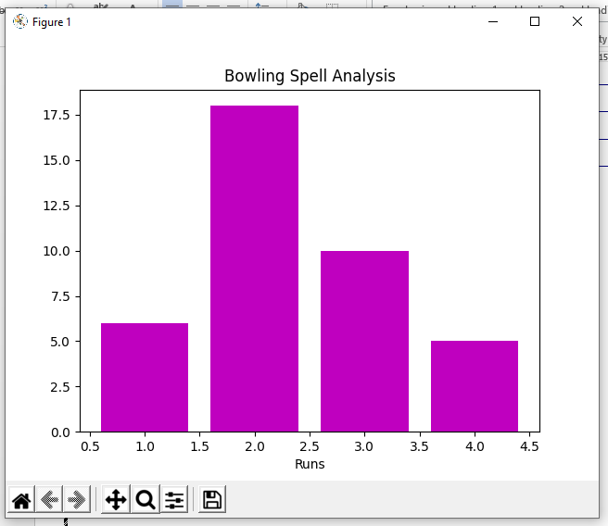

**Part 3: Database query using MySQL**

**20. Create the following table products and write queries given below:**

**Table: Products**

|  |  |  |  |  |
| --- | --- | --- | --- | --- |
| **Pcode** | **Pname** | **Qty** | **Price** | **Company** |
| P1001 | iPad | 120 | 15000 | Apple |
| P1002 | LED TV | 100 | 85000 | Sony |
| P1003 | DSLR Camera | 10 | 25000 | Philips |
| P1004 | iPhone | 50 | 95000 | Apple |
| P1005 | LED TV | 20 | 45000 | MI |
| P1006 | Bluetooth Speaker | 100 | 20000 | Ahuja |

**Constraints:**

1. Pcode – Primary Key
2. Pname – Not Null

**Create table command:**

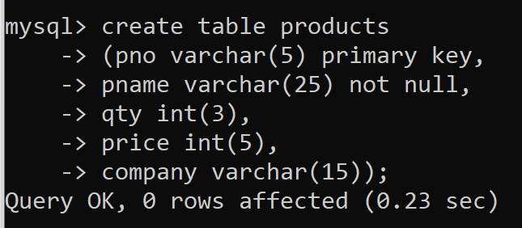

**Insert record command**



1. **To join product and company and display in tabular form like - <pname> manufatured by <company>**

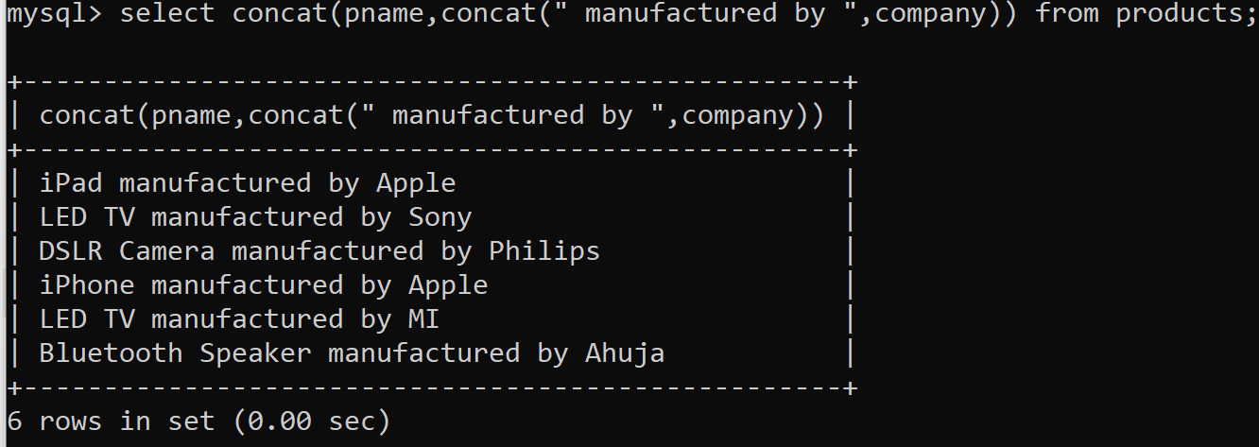

1. **Convert all product name into capital**

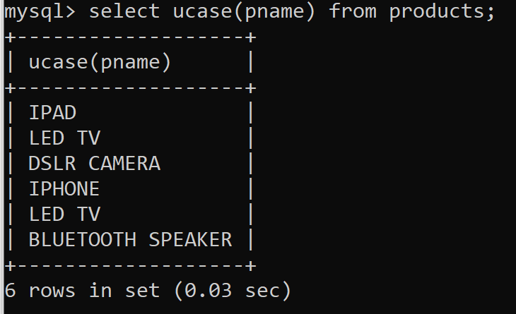

1. **Display the cube of products quantity for more than or 100 in quantty.**

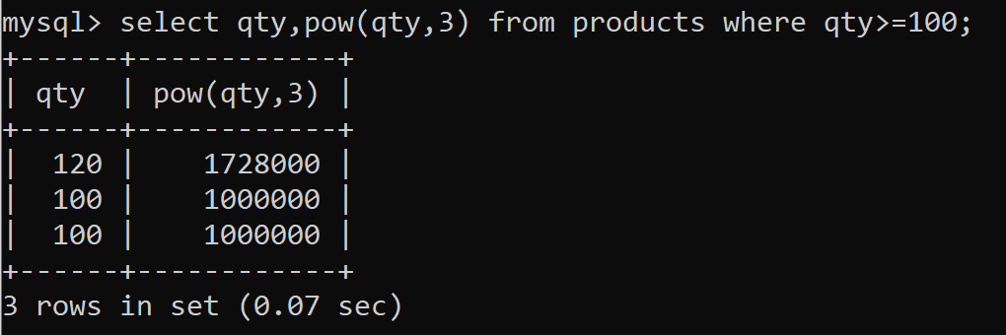

1. **Divide the price by 3 and display the result with 1 fraction digit for price of more than 40,000.**

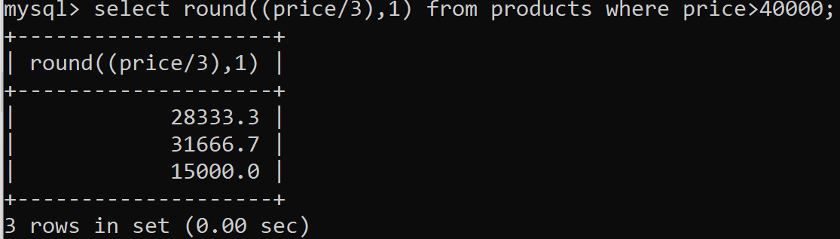

1. **Display pname (last four letters only), qty, price with 2 decimal points and company for price in between 30000 to 80000.**

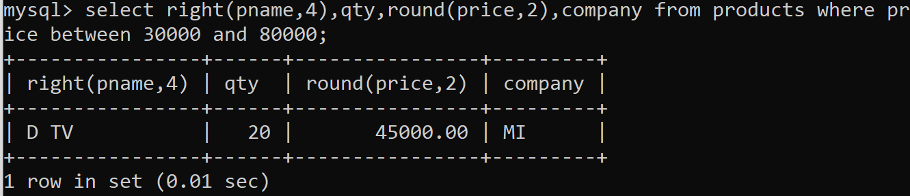

1. **Display maximum price of products**

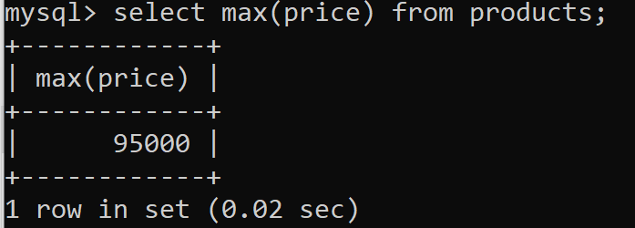

1. **Display the total quantities of all products**

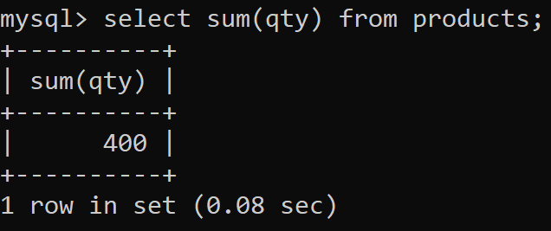

1. **Display the average price of LED TV and Apple products**

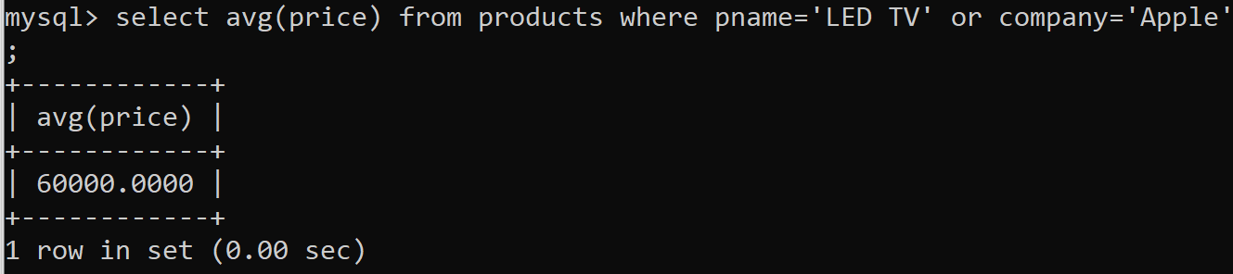

1. **Find the difference between maximum price and minimum price from the table.**

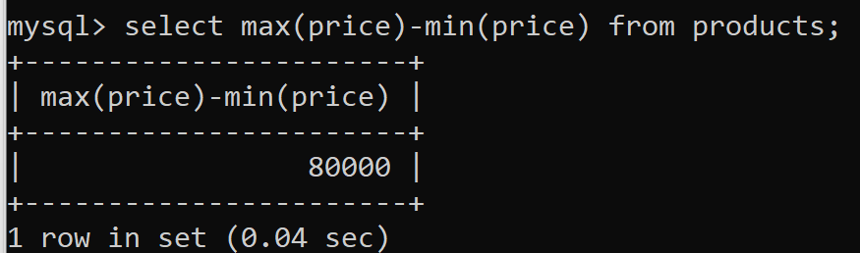

1. **Display unique Products from the table.**

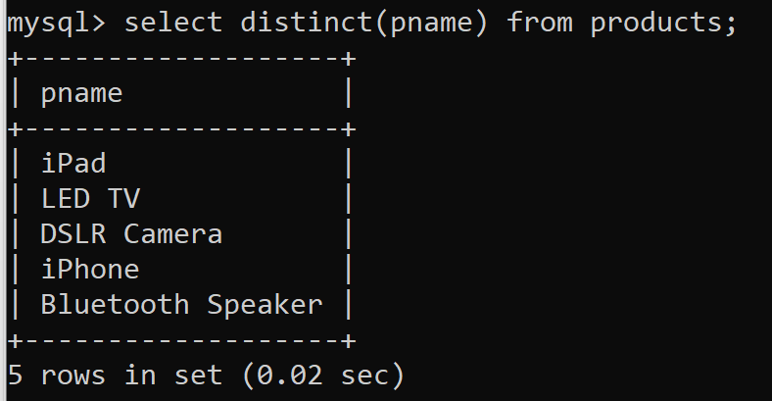

1. **Count the unique company from products.**

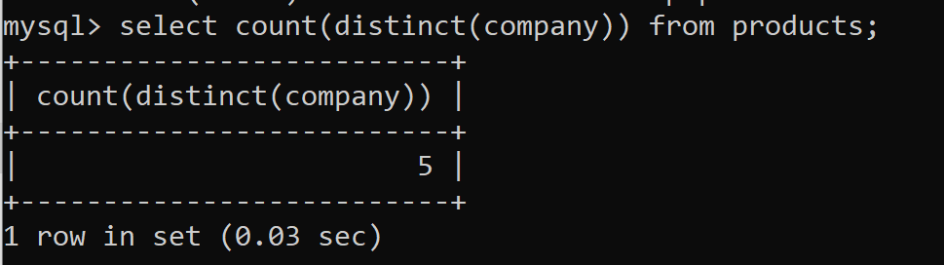

1. **Display the product number, product name and company in the descending order of their price.**

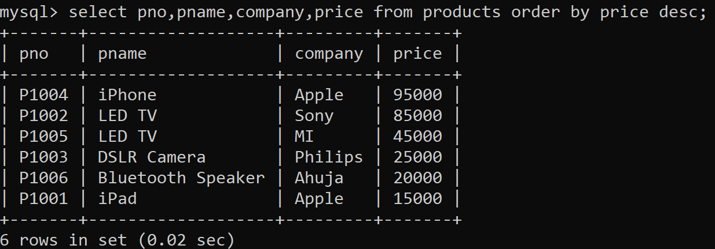

1. **Display product minimum price for each company.**

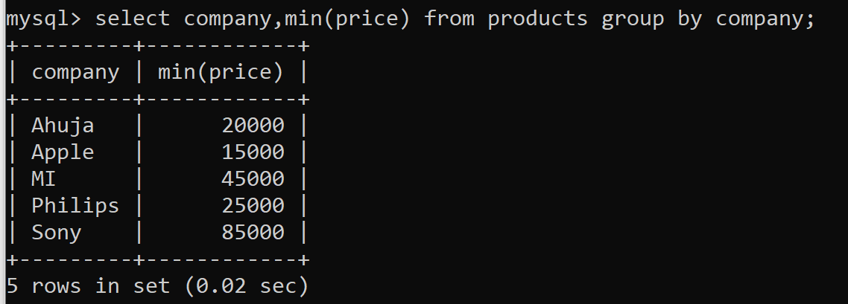

1. **Display product number and product names in their ascending order of names.**

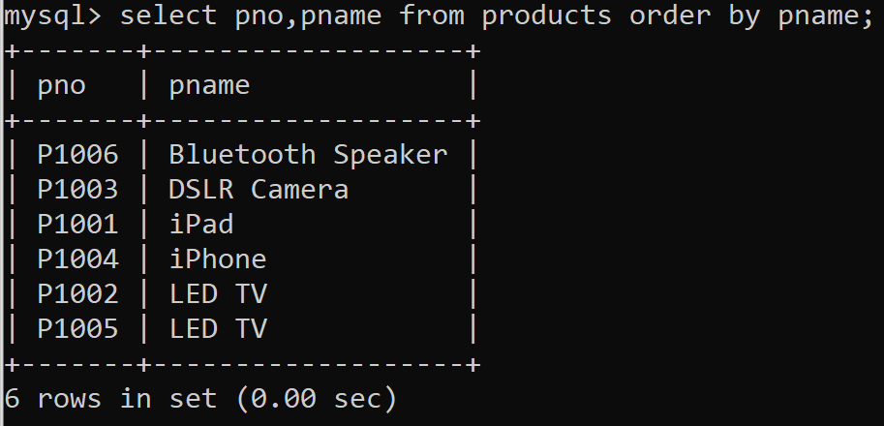

1. **Display maximum price of products manufactured by apple.**

